HACKATHON DAY 7

LIVE DEVELOPMENT AND POST-LAUNCH PRACTICES

Environment Variables Securely Configure

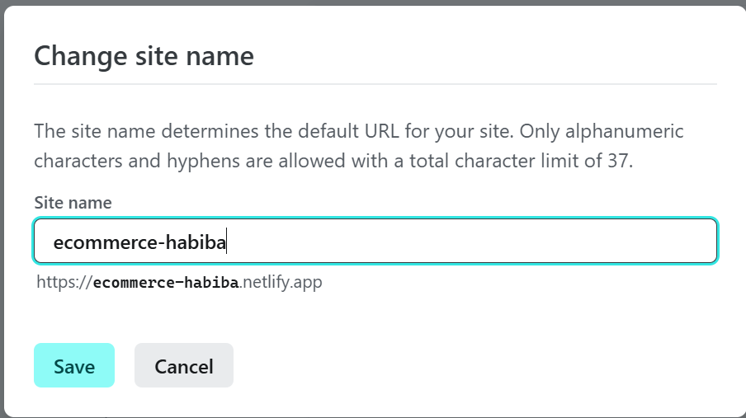

Project -> Site Configuration -> Environment variables

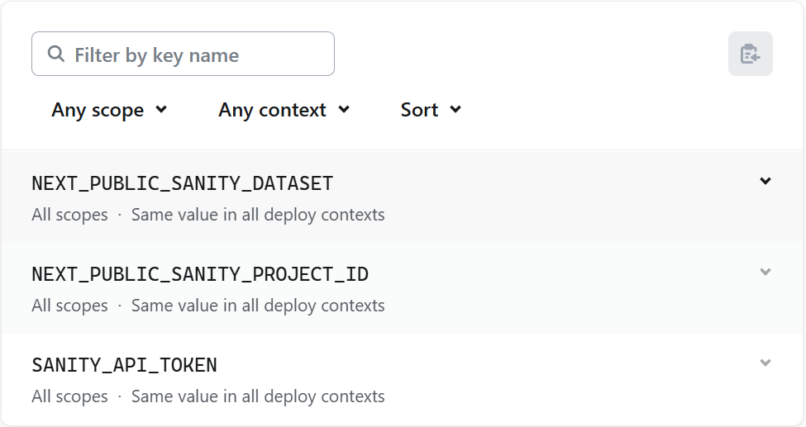

SSL AND HTTPS ENABLE

<https://silly-pie-ba6f3d.netlify.app/>

CODEBASE SECURITY AND REPOSITORY MANAGEMENT

PERFORMANCE OPTIMIZATION

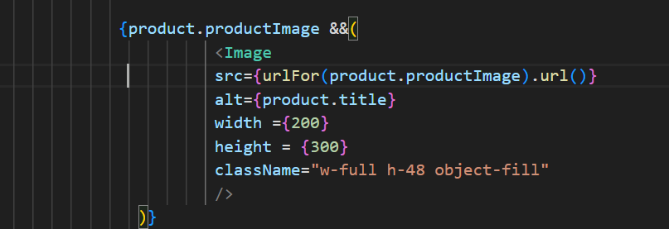

MONITORING AND ANALYTICS TOOLS

BACKUP AND DISASTER RECOVERY